Gabrielle Gaulin June 5th, 2012

Cathay Toile- Brunschwig et Fils

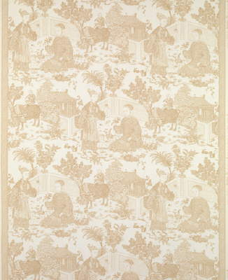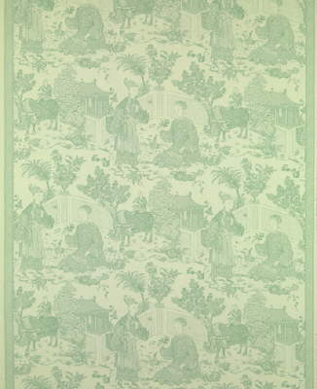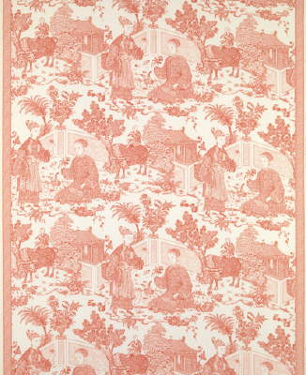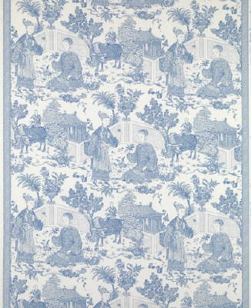

**Company History**

Brunschwig & Fils was established in 1900 by Achille Brunschwig in Aubusson and Bohain, France. Originally a tapestry-only mill, Brunschwig soon expanded its stock to include printed and woven silks and cottons from some of the most highly regarded European mills. When Achille retired from the business, his son Captain Roger E. Brunschwig took over the company. The company quickly expanded and opened show rooms in New York City and other major US cities.

When World War Two left France occupied by Nazi forces, the firm was cut off from French imports and left without a steady product supply. Roger had joined the Free French Forces in 1941, leaving the company leaderless. However, Roger’s wife, an American named Zelina, decided to take matters into her own hands and joined the firm as a stylist. She was able to introduce different fabrics to the line, fabrics such as parachute fabric and muslin that could be produced in America in place of the lost French products. Under her leadership, the line also expanded to include wall coverings and coordinating trimmings. In 1986, Brunschwig & Fils began producing their own upholstered furniture to complement their upholstery fabrics.

Mrs. Brunschwig also made a habit of collecting historical fabrics for archives, much like the Cathay Toile I have picked to specifically study. The company continues this tradition today, with a substantial archive of patterns. The house has sourced inspiration from far and near, including Versailles, the Metropolitan Museum of Art, and Winterthur Museum in Delaware.

**Company Focus**

Brunschwig & FIls produces high quality fabrics that show an attention to detail and the company’s history. Many of their patterns have visible historical precedents that add a regal feeling to the textiles. With comprehensive collections that include fabrics, wallcoverings, trimmings, and upholstered furnishings, Brunschwig & Fils aims to provide a complete look to the consumer.

**Sales**

Brunschwig & Fils is fully owned by Kravet Inc. Like Kravet, Brunschwig & Fils uses the e-designtrade.com web portal to connect with designers. The web portal allows designers to search stock, reserve textiles, request samples, and approve orders. Brunschwig & Fils sells to the trade only.

**Cathay Toile**

**Specifications**

Cathay Toile (Pattern: BR- 79331) is a 100% cotton print, hand silk-screened in an allover color. It is available in three colorways: Coral, Almond, and China Blue (there is one additional colorway, “Jade Flower”, which has been discontinued). The net price of the fabric is $76.00 per yard, with a suggested retail price of $152.00 per yard. The plain weave cotton yarn is ivory in both warp and weft yarns. It is a very large scale pattern, with a vertical repeat of 37 ½” and a horizontal repeat of 33 ¼”. The production of Cathay Toile takes place in France, where it is also hand silkscreened. As the Brunschwig & Fils representative explained to me, roller printing is not an option for this fabric because the repeat is so large. The fabric comes in the standard width of 54” and is suitable as either a drapery or in some cases upholstery in a residential setting. The minimum order size is two yards.

Approximately one full repeat of the pattern.

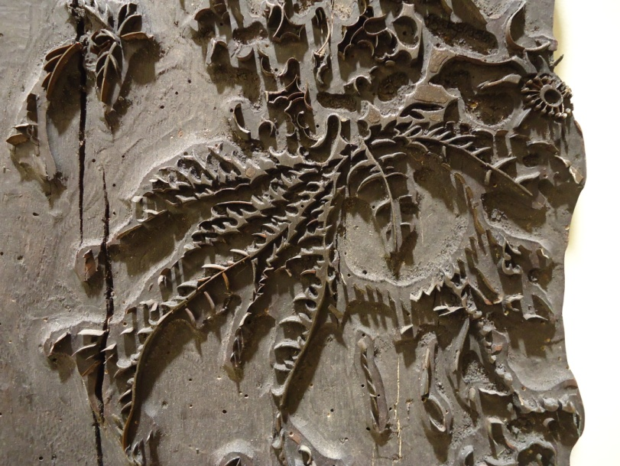**History**

Cathay Toile is actually a documentary design fabric, adapted from an original in the archives of the Society for the Preservation of New England Antiquities in Boston, Massachusetts. The original was a printed linen from England, circa 1750-1760, by the name of “China Blue”. The original printing was done by woodblock. This labor intensive process involves hand carving the negative space of the design so that the resulting block can be dipped in ink and pressed onto the woven fabric. In a design like this, the carver would have to be very skilled in order to produce the thin lines and delicate patterns of the human figures, foliage, animals, and architecture. The woodblock had to be registered by hand, so each yard of the original fabric would have slight irregularities in the print.

An example of a woodblock used for pattern printing from the Brunschwig et Fils showroom.

**Toile vs. Chinoiserie**

As one can tell by the name, the Cathay Toile is a toile print. Toile was created in the Jouy region, characterized by the monochromatic print on a white or off white fabric using copper plates. England, in constant competition with France over style and innovation, also began producing toile prints. However, the English used their native technology of the woodblock in place of copper plates.

Chinoiserie is a type of pattern versus a style of production like toile. The pattern type is a Westernized and romanticized version of Asian motifs. The rage for Orientalism began in the mid 1600s, when European trade with China became more accessible. Lacquer and porcelain were especially popular with wealthy Europeans, and the motifs that were carried with the products were quickly adapted by European artisans. Since Europeans of the time truly knew very little about China (or even outside their village or country), artisans had to use their imaginations to realize a complete motif. Therefore, styles range wildly from semi-authentic to complete fantasy. More importantly, the pattern always featured a fusion between Western and Eastern styles, resulting in an appealing exoticism.

The style of fabric became very popular with the court of Louis XV, who mixed its playful patterns with Rococo styles of furniture and architecture.

**Details**



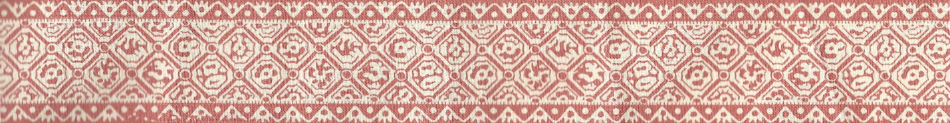Along with its other special characteristics, this textile has an interesting detail along the selvedge edges. The chinoiserie pattern is cropped by a decorative border. This border is actually a Brunschwig & Fils signature detail that is meant to be cut away from the main pattern and used as a trimming for the upholstered piece. The Brunschwig & Fils representative explained to me that the trimming will set apart the upholstery as a designer piece. The Cathay Toile has an inch and a half border, printed in the same shade as the toile, with a pattern that matches one of the architectural details within the pattern. It could be applied to such areas as the hem of a chair skirt to add a finished look.

Works Cited

Brunschwig & Fils. "All about Brunschwig." Brunschwig & Fils. Last modified 2011. http://www.brunschwig.com/about.htm.

Guercio, Alice. "Ask Alice: History of Chinoiserie." *Kravet Inspired News*, May 2012.

Meier, Curtis. Interview by author, Brunschwig et Fils Showroom, Design Marketplace, Philadelphia, PA, May 18, 2012.

Meier, Curtis. "Re: Student- Textile Brand Research Project." E-mail message to the author, May 15,2012.